Aim – Update Document in database.

Learning outcome: Able to configure embedded databases with different web pages using MongoDB.

Duration: 1 hours

List of Hardware/Software requirements:

1. Laptop/Computer with Linux OS - Ubuntu 18.04 LTS
2. MongoDB 6.0.5 Community Edition

**Follow the below step’s**

We have already had a database which name is pglu. we create this database on activity 1.

Step 1: **use pglu** (This is use for choose database which you want to insert values.

Step 2: db.Emp.InsertOne({name:”Anita”, salary: 15000}). (This cmd is to insert a value into the collection and here is Emp is Collection)

**Output:**

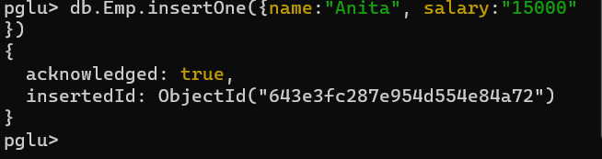

**Update cmd**

Step 3: db.Emp.updateOne({name:”Anita”}, {$set:{name:”Moto”}})

**Input:**

